TABLE OF LIFESAVING SIGNALS
I. LANDING SIGNALS FOR THE GUIDANCE OF SMALL BOATS WITH CREWS OR PERSONS IN DISTRESS
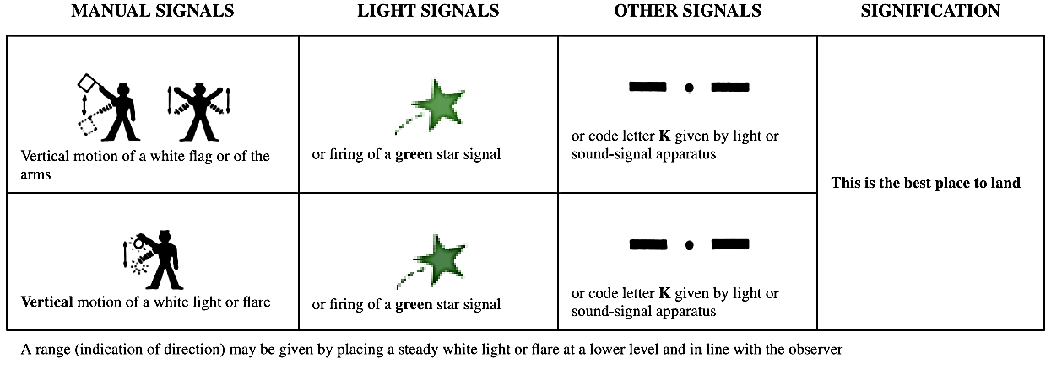

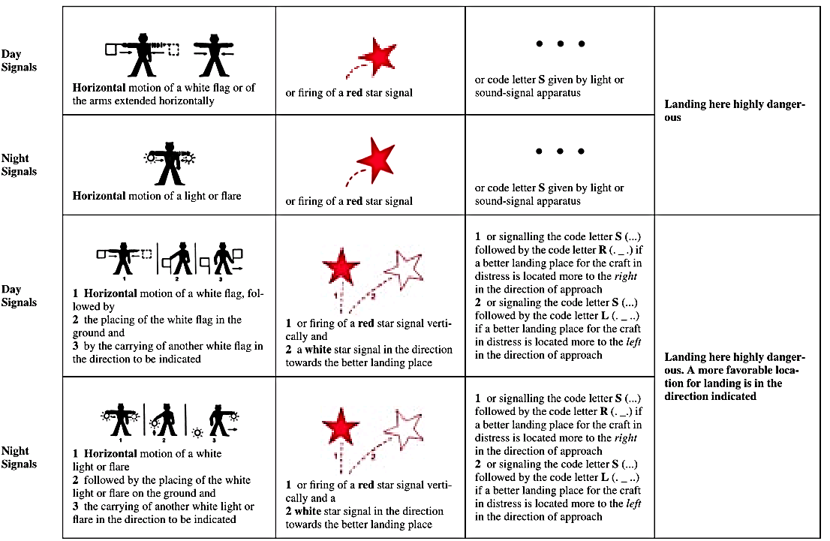

II. SIGNALS TO BE EMPLOYED IN CONNECTION WITH THE USE OF SHORE LIFESAVING APPARATUS
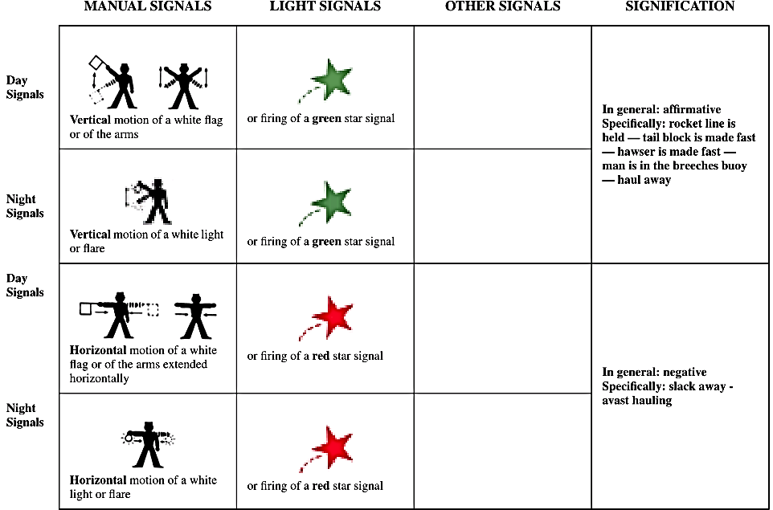

III. REPLIES FROM LIFESAVING STATIONS OR MARITIME RESCUE UNITS TO DISTRESS SIGNALS MADE BY A SHIP OR PERSON
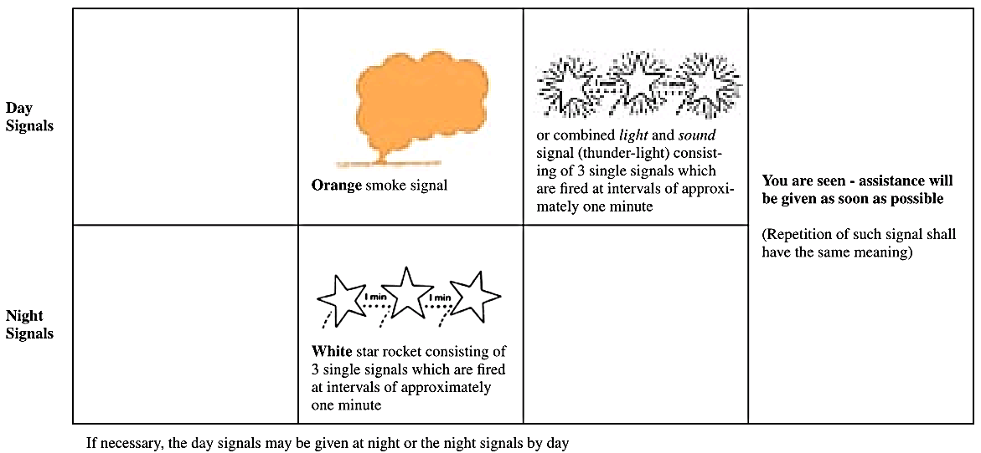

IV. AIR-TO-SURFACE VISUAL SIGNALS
Signals used by aircraft engaged in search and rescue operations to direct ships towards an aircraft, ship or person in distress
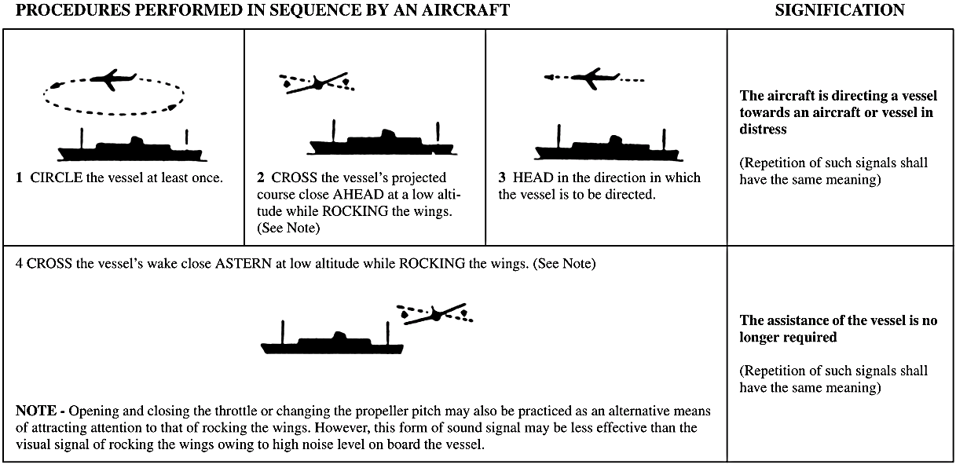

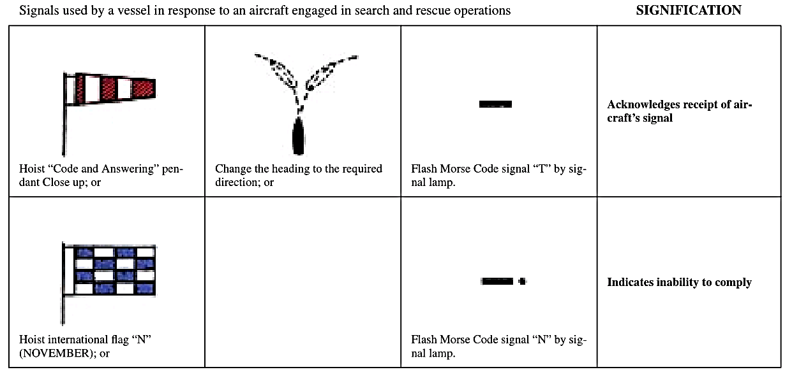

V. SURFACE-TO-AIR VISUAL SIGNALS
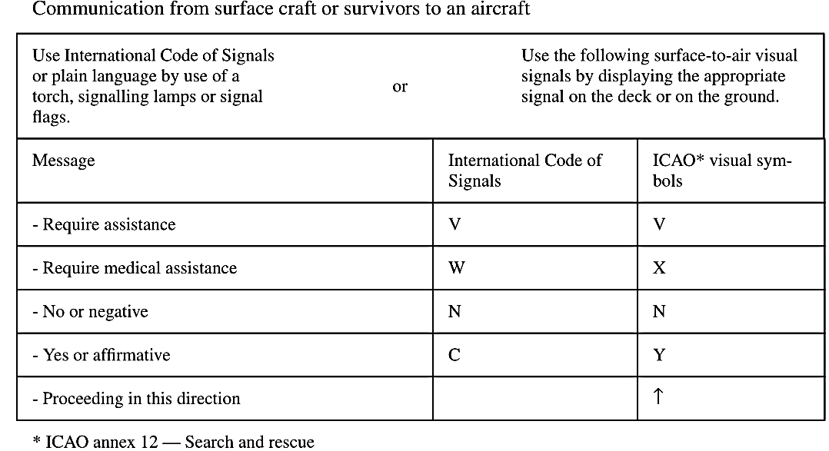
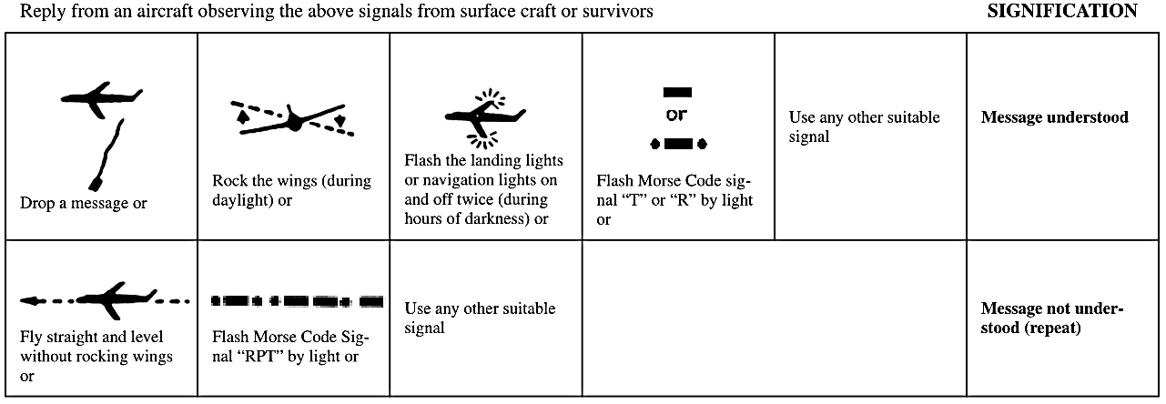
VI. SIGNALS TO SURVIVORS

