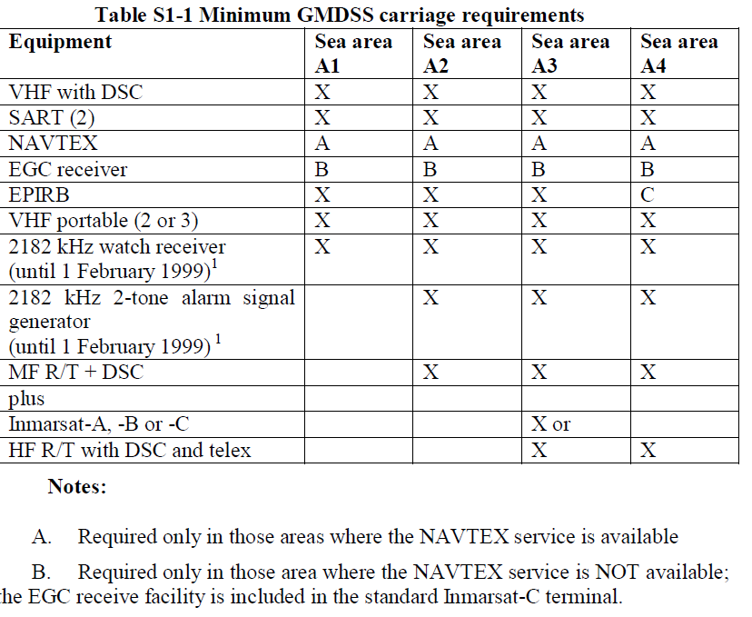
Carriage requirements
Equipment carriage requirements for ship at sea now depend upon the sea in which the ship is sailing. (In the past it was only dependant upon the type/or size of the ship). Furthermore, ships operating in the GMDSS are required to carry a primary and secondary means of distress alerting. This means having VHF DSC as a primary system for a ship near coastal areas, backed up by a satellite Emergency Position-Indicating Radio Beacon (EPIRB). A ship operating in an offshore ocean area could have Medium-Frequency DSC, High-Frequency DSC or Inmarsat satellite communications as a primary system backed up by a satellite EPIRB.
The type of equipment used in the primary system is determined by the sea area in which the ship will be navigating.

Maintenance requirements
The means of ensuring the availability of equipment are determined by the sea areas in which this ship sails (see chapter IV of SOLAS). In sea areas A1 and A2, the availability of equipment shall be ensured by one of the following strategies:
(a) duplication of equipment
(b) shore-based maintenance
(c) et-sea electronic maintenance
(d) or a combination of the above, as may be approved
by the Administration.
In sea areas A3 and A4, the availability of equipment shall be ensured by using a combination of at least two of the above, as may be approved by the Administration.

GMDSS Equipment Introduction

VHF Radiotelephone
Operated in the band 156-174 MHz. Duplex channels are available for Ship/Shore working and simplex channels for Ship/Ship and routine Ship/Shore calling. Maximum range around 30-40 nautical miles, dependent upon heights of antennas.

VHF DSC
Operates on channel 70 and is used for both distress alerting and for routine calling.
VHF Portable Two-way
Radiotelephones
Required for emergency communications from survival craft.
SART
Search and rescue radar transpoder operating on the 3 cm radar X band (9.3-9.5 GHz). Used to help search and rescue (SAR) units to locate survivors.
NAVTEX receiver
Used to receive maritime safety information (MSI) automatically by means of narrowband direct printing from selected stations, using 518 kHz, 490 kHz and 4209.5 kHz.
EPIRBs
Satellite emergency position-indicating radio beacons operate on 406MHz (including 121.5 MHz for homing by rescue aircraft) through the COSPAS-SARSAT network and on 1.6 GHz (L-band Inmarsat-E) through the Inmarsat network. DSC EPIRBs operating on VHF channel 70 may be used in sea areas A1. EPIRB transmission serve to identify
the ship in distress, to inform the RCC of a distress incidents and to help to determine the position of survivors.
Note EPIRB transmissions are regarded as a distress alert

MF/HF DSC
Used to monitor the DSC distress frequencies in the 2, 4, 6, 8, 12 and 16 MHz bands. Also for routine calling or replying on the 2, 4, 6, 8, 12, 16, 18, 22 and 25 MHz bands.
MF/HF transceiver
With full R/T and telex facilities on all the Marine bands.
Note The DSC unit uses this equipment in order to transmit and to await a reply to a routine call
Inmarsat-A/B
Used for voice, telex, data, video and facsimile communications.
Inmarsat-C
Provides telex, data, E-mail and polling on a store-and forward basis. Usually incorporates an EGC (Enhanced Group Call) receiver for the automatic reception of maritime safety information via the International SafetyNET service.
2182 kHz Watchkeeping Receiver
Receiver, with a muted loudspeaker, which is used to listen for the two-tone alarm, upon reception of which the mute is lifted to enable the distress call and message to be heard.
2182 kHz Radiotelephone
Alarm Signal Generator
Fitted into the MF R/T transceiver, it produces the two-tone alarm signal for 1 minute to alert others that a distress call and message is about to follow.
GMDSS ships are required to carry the following minimum equipment:
- A VHF radio installation capable of transmitting DSC on channel 70, and radiotelephony on channels 16, 13 and 6.
- One SART if under 500 GRT, 2 SARTs if over 500 GRT.
- Two portable VHF transceivers for use in survival craft if under 500 GRT, three if over 500 GRT.
- A NAVTEX receiver, if the ship is engaged on voyages in any area where NAVTEX service is provided.
- An Inmarsat EGC receiver, if the ship is engaged on voyages in any area of Inmarsat coverage where MSI services are not provided by NAVTEX or HF NBDP (see note 1).
- A 406 MHz or 1.6 GHz EPIRB
Note 1 - in practice, this means that all GMDSS A3 and A4 vessels are required to carry at least one Inmarsat C system.
Radio equipment - Sea area Al
Every ship engaged on voyages exclusively in sea area A1 shall be provided with the minimum equipment specified previously, with the option to replace the 406 EPIRB with a VHF DSC EPIRB.

Radio equipment - Sea areas A1 and A2
Every ship engaged on voyages beyond sea area A1, but remaining within sea area A2, shall be provided with the minimum equipment specified previously, plus:
- An MF radio installation capable of transmitting and receiving on the frequencies 2187.5 kHz using DSC and 2182 kHz using radiotelephony;
- a DSC watchkeeping receiver operating on 2187.5 kHz
- A 406 MHz EPIRB

The ship shall, in addition, be capable of transmitting and receiving general radio communications using radiotelephony or direct-printing telegraphy by:
- A HF radio installation operating on working frequencies in the (marine) bands between 1,605 kHz and 27,500 kHz. (This requirement is normally fulfilled by the addition of this capability in the MF equipment referred to earlier).
Radio equipment - Sea areas A1, A2 and A3
These vessels have two options to satisfy their GMDSS requirements. The options allow a vessel to choose from the primary method to be used for ship-shore alerting ;
Every ship engaged on voyages beyond sea areas A1 and A2, but remaining within sea area A3 shall be provided with the minimum equipment specified previously, plus either:
- An Inmarsat C ship earth station :
- An MF radio installation and 2187.5 kHz DSC watchkeeping receiver;
- A 406 MHz EPIRB
or
- An MF/HF radio installation capable of transmitting and receiving on all distress and safety frequencies in the (marine) bands between 1,605 kHz and 27,500 kHz: using DSC, radiotelephony; and NBDP
- An MF/HF DSC watchkeeping receiver capable of maintaining DSC watch on 2,187.5 kHz, 8,414.5 kHz and on at least one of the distress and safety DSC frequencies 4,207.5 kHz, 6,312 kHz, 12,577 kHz or 16,804.5 kHz; at any time, it shall be possible to select any of these DSC distress and safety frequencies
- A 406 MHz EPIRB
- An Inmarsat ship earth station

In addition, ships shall be capable of transmitting and receiving general radiocommunications using radiotelephony or direct-printing telegraphy by an MF/HF radio installation operating on working frequencies in the (marine) bands between 1,605 kHz and 27,500 kHz. This requirement is normally fulfilled by the addition of this capability in the MF/HF equipment referred to earlier. In practice, MF only transceivers are not produced - all marine MF radio equipment is
also fitted with HF facilities.
Radio equipment - Sea areas Al, A2, A3 and A4
In addition to carrying the equipment listed previously, every ship engaged on voyages in all sea areas shall be provided with:
- An MF/HF radio installation as described earlier
- An MF/HF DSC watchkeeping receiver as described earlier
- A 406 MHz EPIRB
In addition, ships shall be capable of transmitting and receiving general radio communications using radiotelephony or direct-printing telegraphy by an MF/HF radio installation as described earlier.

Equipment to be duplicated for area A3 vessels
GMDSS ships operating in A3 areas are required to provide the following duplicated equipment:
- Two complete VHF installations (including DSC), and either;
- Two complete Inmarsat C systems and one MF radio system, or;
- One complete Inmarsat C system and one complete MF/HF radio system (including a scanning DSC receiver and NBDP equipment).
Many GMDSS ships opt for the latter option (1 Inmarsat C and one MF/HF DSC system), on cost grounds. Unfortunately, this has proven to be one of the underlying causes of the present extremely high false alerting rate on some GMDSS systems.
Power supply requirements
GMDSS equipment is required to be powered from three sources of supply:
- ship's normal alternators/generators;
- ship's emergency alternator/generator (if fitted); and
- a dedicated radio battery supply.
The batteries are required to have a capacity to power the equipment for 1 hour on ships with an emergency generator, and 6 hours on ships not fitted with an emergency generator.
The batteries must be charged by an automatic charger, which is also required to be powered from the main and emergency generators.
Changeover from AC to battery supply must be automatic, and effected in such a way that any any data held by the equipment is not corrupted (ie: "no break").

Operator qualifications
There are a number of different types of GMDSS qualifications, as follows:
- First Class Radio-Electronic Certificate;
- Second Class Radio-Electronic Certificate; and
- GMDSS General Operator's Certificate
The First and Second Radio-Electronic Certificates are diploma and associate diploma level technical qualifications. They are designed for Ship's Radio-Electronic Officers, who sail on GMDSS ships which use the option of at-sea electronic maintenance.
The GMDSS General Operator's Certificate is a operator qualification, designed for Navigating Officers.
Survival Craft Radio Equipment
Search And Rescue (Radar) Transponders (SARTs)
SART is a self contained, portable and buoyant Radar Transponder (receiver and transmitter).
SARTs operate in the 9 GHz marine radar band, and when interrogated by a searching ship's radar, respond with a signal which is displayed as a series of dots on a radar screen.
Although SARTs are primarily designed to be used in lifeboats or liferafts, they can be deployed on board a ship, or even in the water.
SARTs are powered by integral batteries which are designed to provide up to 96 hours of operation.
Operation
When activated, a SART responds to a searching radar interrogation by generating a swept frequency signal which is displayed on a radar screen as a line of 12 dots extending outward from the SARTs position along its line of bearing.
The spacing between each dot is 0.6 nautical miles.
As the searching vessel approaches the SART, the radar display will change to wide arcs. These may eventually change to complete circles as the SART becomes continually triggered by the searching ship's radar.
Some slight position error will also be caused by the SART switching from receive to transmit mode.
SARTs will also provide a visual and audible indication to users when interrogated by a searching radar.
Range
The range achievable from a SART is directly proportional to its height above the water. A SART mounted at 1m (ie: in a liferaft) should be able to be detected at 5 nautical miles by a ship's radar mounted at 15m. The same SART should be able to be detected at 30 nautical miles by an aircraft flying at 8000 feet.

Portable VHF transceivers
These units are designed to allow communications between searching vessels and survivors in liferafts. They operate on the VHF marine band in voice mode. DSC capability is not fitted.
Performance standards
The IMO performance standard requires that the equipment:
- provide operation on VHF channel 16 (the radiotelephone distress and calling channel) and one other channel
- be capable of operation by unskilled personnel
- be capable of operation by personnel wearing gloves
- be capable of single handed operation, except for channel changing
- withstand drops on to a hard surface from a height of 1 metre
- be watertight to a depth of 1 metre for at least 5 minutes, and maintain watertightness when subjected to a thermal shock of 45 degrees Celsius.
- not be unduly effected by seawater or oil
- have no sharp projections which could damage survival craft
- be of small size and weight
- be capable of operating in the ambient noise level likely to be encountered on board survival craft
- have provisions for attachment to the clothing of the user
- be either a highly visible yellow/orange colour or marked with a surrounding yellow/orange marking strip
- be resistant to deterioration by prolonged exposure to sunlight

GMDSS Master Plan
Contains information to users on shore-based facilities regarding space and terrestrial communications services for the GMDSS.
LIST OF ANNEXES
ANNEX 1 - STATUS OF SHORE-BASED FACILITIES FOR THE GMDSS
ANNEX 2 - LIST OF VHF DSC COAST STATIONS FOR SEA AREAS A1
ANNEX 3 - LIST OF MF DSC COAST STATIONS FOR SEA AREAS A2
ANNEX 4 - LIST OF HF DSC COAST STATIONS FOR SEA AREAS A3 AND A4
ANNEX 5 - LIST OF INMARSAT LAND EARTH STATIONS (LESs)
ANNEX 6 - LIST OF RESCUE COORDINATION CENTRES (RCCs) USING SHIP EARTH STATIONS (SESs)
ANNEX 7 - NAVTEX SERVICE
ANNEX 8 - THE INTERNATIONAL SAFETYNET SERVICE APPENDICES
TABLE OF INTERNATIONALLY COORDINATED BROADCAST SCHEDULES
ANNEX 9 - HF NARROW BAND DIRECT PRINTING (NBDP) MARITIME
SAFETY INFORMATION (MSI) BROADCAST SERVICE
ANNEX 10 - LIST OF COSPAS-SARSAT MISSION CONTROL CENTRES
(MCC) AND LOCAL USER TERMINALS (LUT)
ANNEX 11 - SATELLITE EPIRB REGISTRATION INFORMATION/DATA
ANNEX 12 - LIST OF 24 HOUR POINTS OF CONTACT FOR MARITIME
MOBILE SERVICE IDENTITIES (MMSI)
ANNEX 13 - QUESTIONNAIRE ON SHORE-BASED FACILITIES FOR THE
GMDSS (MSC.1/Circ.1382)

